SHIP ENERGY EFFICIENCY MANAGEMENT PLAN (SEEMP) PART II

“MT”

 |  |  | Client :
Prepared by |  | UID Number |  | Date
Checked by |  | Job Number |  | Total Pages
Approved by |  | Document Number |  | Revision

SHIP ENERGY EFFICIENCY MANAGEMENT PLAN (SEEMP) PART II MT

SHIP ENERGY EFFICIENCY MANAGEMENT PLAN (SEEMP) PART II

MT
IMO:

This is reviewed for adequacy as per Reg.27.1 & 27.2, MEPC 346(78) & 385(81) of MARPOL Annex VI

1

TABLE OF CONTENTS

- INTRODUCTION 3
- OBJECTIVES 3
- REVIEW AND UPDATE LOG 4
- SHIP PARTICULARS 5
- RECORD OF REVISION OF FUEL OIL CONSUMPTION DATA COLLECTION PLAN 6
- SHIP ENGINES AND OTHER FUEL OIL CONSUMERS AND FUEL OIL TYPES USED 7
- EMISSION FACTOR 7
- METHOD TO MEASURE FUEL OIL CONSUMPTION 8
- METHOD TO MEASURE DISTANCE TRAVELLED 9
- METHOD TO MEASURE HOURS UNDERWAY AND TRANSPORT WORK. 9
- PROCESSES THAT WILL BE USED TO REPORT THE DATA TO THE ADMINISTRATION 10
- DATA QUALITY 10
APPENDIX 1 12
INFORMATION TO BE SUBMITTED TO THE IMO SHIP FUEL OIL CONSUMPTION DATABASE (REGULATION 27) 12
APPENDIX - 2 16
SAMPLE OF THE BDN SUMMARIES 16
APPENDIX - 3 18
SAMPLE OF THE COLLECTED DATA SUMMARY & STANDARDIZED DATA REPORTING FORMAT FOR THE DATA COLLECTION SYSTEM 18

Introduction

The SEEMP Part II has been developed in accordance with the MARPOL Annex VI Resolution MEPC.346 (78) (adopted on 10 June 2022) & MEPC 385 (81) (adopted on 22 March 2024).

The purpose of the plan is to develop a ship-specific method to collect, aggregate and report ship data with regard to annual fuel oil consumption, distance travelled, hours underway, and other data required by Regulation 27 of MARPOL Annex VI to be reported to the Administration.

Pursuant to regulation 5.4.5 of MARPOL Annex VI, the Administration should ensure that each covered ship's SEEMP complies with regulation 26.2 of MARPOL Annex VI prior to collecting any data.

This Plan has been reviewed by Class or administration and no alteration or revision shall be made to any of it without the prior approval of the administration or Class.

Objectives

The data collection plan contains the following information:
  - Description of the method used to measure annual fuel oil consumption.
  - Description of the method used to measure distance traveled.
  - Description of the method used to measure hours underway.
  - Description of the method used to aggregate data.
  - Description of the data quality control measures.
  - Description of the processes that will be used to report the data.

Review and update log

Date/timeline | Updated parts | Developed by | Implemented by
 | Initial Issue |  | Onboard : Master, Chief Engineer & Crew Onshore:

Ship Particulars

NAME OF SHIP | MT
IMO NUMBER | 000000000
COMPANY | SHIP MANAGEMENT
CLASSIFICATION SOCIETY | CLASS
FLAG | FLAG
PORT OF REGISTRY | PORT
KEEL LAID
DATE OF BUILT | 00-00-2025
SHIP TYPE | OIL TANKER
GROSS TONNAGE | 00000
NET TONNAGE | 00000
DEADWEIGHT | 00000
Draft | 00.00 m
ATTAINED EEDI | NOT APPLICABLE
EEXI (if applicable)
ICE CLASS | NOT APPLICABLE
Fuel Consumers | Main Engine, Aux Engine, Boiler, IGG, HPP

Record of revision of Fuel Oil Consumption Data Collection Plan

Date of Revision | Revised Provision

6 Ship Engines and other fuel consumers and fuel oil types used

EQUIPMENT | TECHNICAL DESCRIPTION OF EMISSIONS SOURCE  (Performance/power, specific fuel oil consumption, year of installation, identification number in case of multiple identical emission sources etc.) | TYPE OF FUEL  CONS.
MAIN ENGINE | STX MAN-B&W 6S60ME-C, POWER MCR – 18436 HP,13560 kW, 105 RPM 169 gr/kWh | HFO/MGO
AUXILIARY  ENGINES NO. 1 | STX MAN-B&W 6L23/30H, MAX POWER - 960 kW, 900  rpm, 195 gr/kWh | HFO/MGO
AUXILIARY  ENGINES NO. 2 | STX MAN-B&W 6L23/30H, MAX POWER - 960 kW, 900  rpm, 195 gr/kWh | HFO/MGO
AUXILIARY  ENGINES NO. 3 | STX MAN-B&W 6L23/30H, MAX POWER - 960 kW, 900  rpm, 195 gr/kWh | HFO/MGO
BOILERS | KANGRIM HEAVY IND., MB06S01A, 18000 KG/H | HFO/MGO`
INERT GAS  GENERATORS | HAMWORTHY KSE, Capacity -4500 m3/h, | MDO/MGO
FRAMO  H.P.P.E. x 2 | CUMMINS, KTA 19-DMI 425 kW, 1800 rpm, 210 gr/kWh | MDO/MGO

In Order to achieve Granularity following measure are take:

- Monthly CII tracking by office.
- Voyage-specific CII calculations by office to monitor CII rating change.
- Segmented fuel consumption data (per engine, generator, or operational mode).

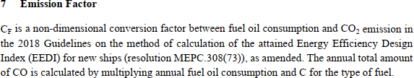

Fuel oil type | C_{F}  (t-C02 / t-Fuel)
Diesel/Gas oil (e.g. ISO 8217 grades DMX through DMB) | 3.206
Light fuel oil (LEO) (e.g. ISO 8217 grades RMA through RMD) | 3.151
fuel oil HFO (e.g. ISO 8217 rades RME through RMK) | 3.114
Liquefied petroleum gas (LPG) (Propane) | 3.000
Liquefied petroleum gas (LPG) (Butane) | 3.030
Liquefied natural gas (LNG) | 2.750
Methanol | 1.375
Ethanol | 1.913
Other

8 Method to measure fuel consumption:

Methods to measure fuel consumption:

- Individual consumer Flow meters.
- Monitoring tank sounding as per consumption and transfer from bunker tanks to settling/ service tanks.

  - Daily fuel consumption data is collected at noon (last 24 hrs) and send to office for review.

  - Individual fuel consumers such as Main Engine, Aux Engine, Boiler etc fuel consumption is recorded separately in IMO data sheet as mentioned in Appendix 2

  - Each type of Fuel consumption is recorded separately for individual consumers in noon report and same is followed in IMO DCS data reporting as in Appendix 2.

  - Daily fuel consumption monitoring is done by monitoring service/settling tank and flow meters of consumers.

Method To Measure Shore Power supplied:

- Emergency DG shore Power meter reading is used to measure shore power supplied.

- Shore power meter will be used to verify onboard Power meter shore power consumption supply.

Following Additional data added for Energy Efficiency Calculation:
- Transport Work = Cargo Carried * Distance Traveled.
- Voyage Report to calculate Distance traveled.
- ME Running Parameters to calculate ME efficiency.

Data is shared to office on Daily basis and monthly report. Office to perform annual audit to verify the correctness and accuracy of data.
Monthly monitoring by office to verify the month end fuel consumption report.

SHIP ENERGY EFFICIENCY MANAGEMENT PLAN (SEEMP) PART II MT

Total Yearly Fuel oil Consumption

The Company will use Bunker Fuel Delivery Note (BDN) for monitoring the fuel consumption during reporting period.
Company determines the method of calculation of consumed fuel quantity per fuel type during a reporting period as follows:
(ROB quantity in applicable tanks at 1st day 00:01 GMT + Bunkered fuel during all period) - (ROB quantity in applicable tanks at Last day of reporting period on 24:00 GMT) = (consumed fuel during all reporting period)
The formula to be used per fuel type consumed is as follows:
i : Fuel type
IROB: Initial quantity in applicable tanks on 1st day of collection period at 00:01 GMT Bf: Bunkered fuel during all data collection period
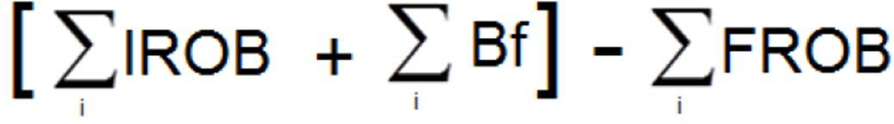
FROB: Final quantity in applicable tanks on Last day of collection period at 24:00 GMT Total Fuel Consumed =
Fuel which for any reason not consumed in vessel’s applicable equipment/installations (eg. due to spill or re transferred to other vessel), should not be included in the calculation.

This is based on the quantity and type of fuel as defined on the BDN combined with periodic stock-takes of fuel tanks based on tank readings.
For each fuel oil to be used on board a Bunker Delivery Note (BDN) provided by the suppliers should be available containing at least the following information as per MARPOL ANNEX VI Appendix 5:

- Name and IMO number of receiving ship
- Port
- Date of commencement of delivery
- Name, Address, and telephone number of marine fuel supplier
- Products name(s)
- Quantity (metric tons)
- Density at 15 deg C (kg/m3)
- Sulphur content (% m/m)
- A declaration signed and certified by the fuel oil supplier’s representative that the fuel oil supplied is in conformity with regulation 14(1) or (4)(a) and regulation 18(1) of MARPOL 73/78 Annex VI

The BDN has to be kept on board for at least 3 years and be readily available for inspection at all reasonable times. Furthermore, a representative sample of the bunkered fuel oil must be retained under the ship’s control until the fuel oil is substantially consumed, but in any case, not less than 12 months from the time of delivery. The representative sample of fuel oil must be sealed & signed by the supplier of the fuel oil & the master of the ship.

8

Fuel tank readings shall be carried out by appropriate methods such as automated systems, soundings and dip tapes.

Where the amount of fuel uplift or the amount of fuel remaining in the tanks is determined in units of volume, expressed in litres, the company converts that amount from volume to mass by using actual density values. The company determines the actual density by using one of the following:

a. The density measured in a test analysis conducted in an accredited fuel test laboratory, where available.
The actual density shall be expressed in kg/l and determined for the applicable temperature for a specific measurement.
The factor BF (Bunkered fuel) in calculation formula is to be calculated per fuel type as follows:
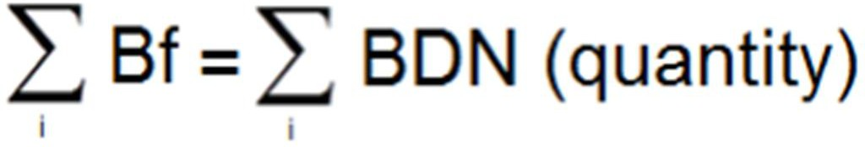

Method to measure distance travelled

Distance travelled over ground in nautical miles are recorded in the logbook in accordance with SOLAS regulation V/28.1;6. The recording of distance travelled is done through the deck logbook which are reviewed by master. Logbook entries are made in a daily basis. The information are recorded daily into the form and reported to the company by daily/arrival/departure reports by master.

The distance travelled is calculated by actual distance travelled, as contained in the ship’s log- book, vessel’s speed log and GPS. The summary of distance calculated in passage plans may be used for reference or for verification purposes.

The distance travelled is calculated from Bridge log book and/or speed log, and/or GPS data, starting on the first day (00:01 GMT) of reporting period and concluding on the last day (24:00 GMT) of reporting period.

Transport Work calculation:

Transport work for each voyage = Distance Sailed (nautical miles) * Carried cargo (mt) Total Transport Work (TTW)=∑(DWT×Distance Traveled)
DWT = Deadweight tonnage (in metric tons) – represents the cargo-carrying capacity of the ship.
Distance Traveled = The nautical miles traveled during the reporting period (e.g., annually).

- Method to measure hours underway

Hours underway should be an aggregated duration while the ship is underway under its own propulsion.
Company determines that for calculating the total hours underway to the reporting period as the summary of daily hours spent at sea under vessel’s own propulsion (including in port tug operations while main engine and auxiliary engines are running) , on the first day (00:01 GMT) of reporting period and concluding on the last day (24:00 GMT) of reporting period.

Processes that will be used to report the data to the Administration

The vessel prepares “Voyage Status Log” based respectively on the Deck log book and Engine log book every day during the preparation of Daily Report. Fuel consumption and other relevant data is recorded manually on board. The vessel is reporting the data in the form daily to the office in standardized formats; the data is then stored, processed, and analysed ashore. The vessel is reporting the data in electronic form daily to the office in standardized formats. After the end of calendar year, Company aggregates the data into annual value and reports the data to the Administration

Data quality

The Company uses certain methods to estimate fuel consumption and other parameters if relevant data is missing:

  - Accuracy gaps in fuel consumption measurement
  - Missing data regarding distance travelled
  - Missing data regarding time spent at sea.
Data flows either manually (through noon reports), or semi-automatically with human intervention or finally through a continuous real-time monitoring system.
The Company recognized three steps to treat data gaps:

- Creates a logical sequence of data collection and processing:
  - Reading from instruments,
  - Converting volume to mass
  - Transferring data
  - Processing, storing, retrieving
- Assess the risks associated with this data flow and set up control measures:
  - Errors
  - Misrepresentations
  - Omissions
- After the application of control measures, re-assess the risks:
  - Ensure Controls have been effectively applied.
  - Remaining risks are sufficiently low

Accuracy gaps in fuel consumption measurement
Bunker Fuel Delivery Note (BDN)
The accuracy of BDN data varies depending on how the fuel quantity stated on the BDN is determined. BDNs have an accuracy level of 1 to 5%, disputes over the quality and quantity of fuel is common between bunkers and ship operators. The BDNs also provide information on the quality of the fuel that is bunkered.

BDN calculated data is checked against daily noon consumption record and supply of bunker.

Company determines the corrective factor to declared fuel quantities measured with this method to be 5%

Method to treat data gaps regarding distance travelled

The Company, in order to treat possible data gaps regarding distance travelled sets a specific method to ensure proper fuel consumption estimation. Data regarding distance travelled sent to office shall be compared with:

- Distance calculated in passage plan
- Distance calculated in GPS and
- Distance from extract of vessel’s speed log.

Methods to treat data gaps regarding time spent at sea.

Company sets specific method for treating gaps relating to time spent at sea. Data derived from noon reports, arrival and departure reports, engine running hour’s reports and real time monitoring systems to be compared to ensure accuracy.

Innovative Technology installed :
- Using Silicon based hull paint
- Use of low energy lighting system.
- Weather Routing.
- Minimizing Boiler operation using efficient cut-in cut-off pressure monitoring arrangement.

Appendix 1

INFORMATION TO BE SUBMITTED TO THE IMO SHIP FUEL OIL CONSUMPTION DATABASE (REGULATION 27)

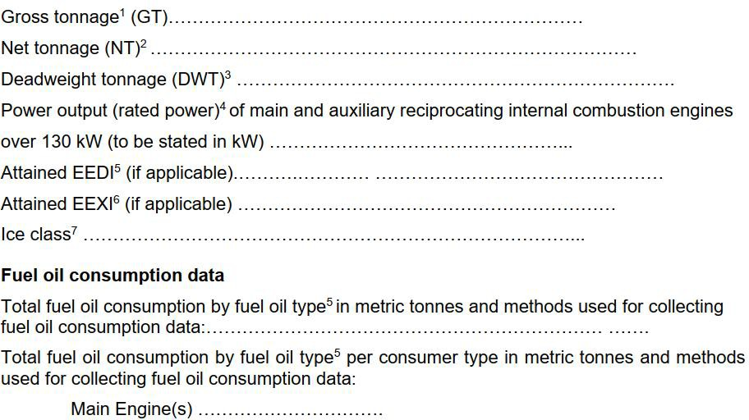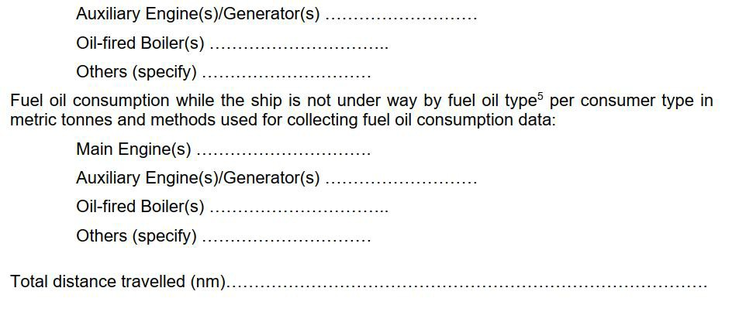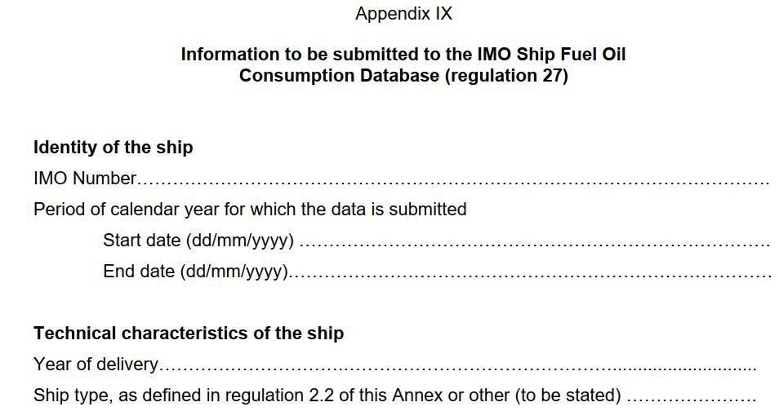

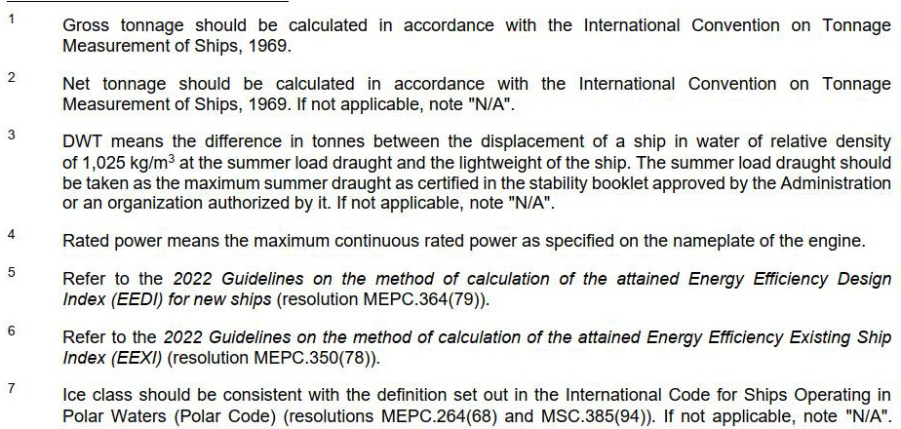
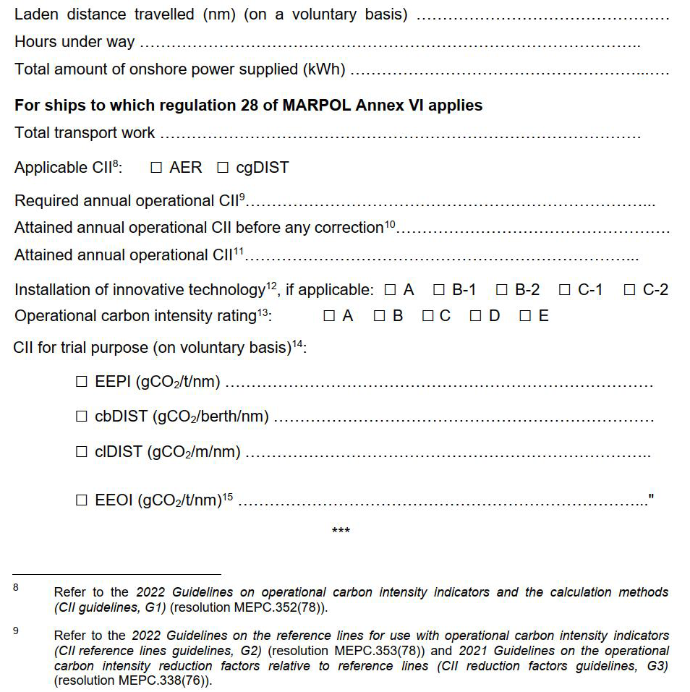

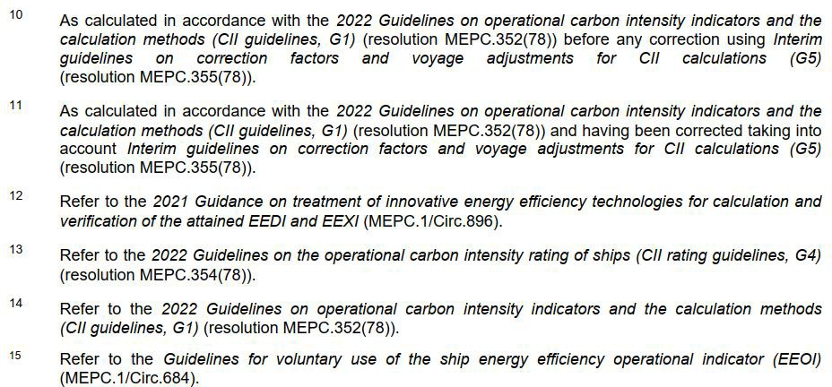

Appendix - 2

SAMPLE OF THE BDN SUMMARIES

SHIP ENERGY EFFICIENCY MANAGEMENT PLAN (SEEMP) PART II MT

Date of  Operations (dd/mm/yyyy) | Fuel Oil Type/Mass(MT) |  |  |  |  |  |  | Descriptions
Date of  Operations (dd/mm/yyyy) | DO/GO | LFO | HFO | LPG(P) | LPG(B) | LNG | Others(CF) | Descriptions
1. BDN
1.Annual Supply Amount | 0 | 0 |  | 0 | 0 | 0 | 0
2. Correction for the tank oil remaining
2.Correction for  the tank oil remainings | 0 | 0 |  | 0 | 0 | 0 | 0 | The difference in the amount of the remaining tank oil at the beginning/end of the data collection period.
3. Other corrections
3. Annual Other Corrections
Annual Fuel Consumption
Annual Fuel Consumption  1+2+3 | 0 | 0 |  | 0 | 0 | 0 | 0

17

SHIP ENERGY EFFICIENCY MANAGEMENT PLAN (SEEMP) PART II MT

Appendix - 3

SAMPLE OF THE COLLECTED DATA SUMMARY & STANDARDIZED DATA REPORTING FORMAT FOR THE DATA COLLECTION SYSTEM

18

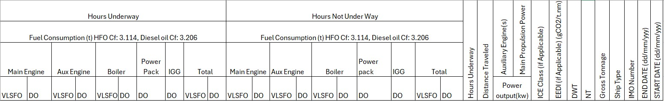
- In accordance with the /MO Ship Identification Number Scheme, adopted by the Organization by resolution A.1078(28).
Fuel Consumption MT
Main Engine
Aux Engine
Boiler
VLSFO
VLSFO
VLSFO
DO
DO
DO
- As defined in regulation 2 of MARPOL Annex VI or other (to be stated).
- Gross tonnage should be calculated in accordance with the International Convention on Tonnage Measurement of Ships, 1969.
- NT should be calculated in accordance with the International Convention on Tonnage Measurement of Ships, 1969. If not applicable, note "NIA".
- DWT means the difference in tonnes between the displacement of a ship in water of relative density of 1025 kglm3 at the summer load draught and the lightweight of the ship. The summer load draught should be taken as the maximum summer draught as certified in the stability booklet approved by the Administration or an organization recognized by it.
- EEDI should be calculated in accordance with the 2014 Guidelines on the method of calculation of the attained Energy Efficiency Design Index (EEO/) for new ships, as amended, adopted by resolution MEPC 245(66). If not applicable, note "NIA".
- Ice class should be consistent with the definition set out in the International Code for ships operating in polar waters (Polar Code), adopted by resolutions MEPC.264(68)
and MSC.385(94)) If not applicable, note "NIA".
- Power output (rated power) of main and auxiliary reciprocating internal combustion engines over 130 kW (to be stated in kW). Rated power means the maximum continuous rated power as specified on the nameplate of the engine.
- Method used to measure fuel oil consumption: 1: method using BDNs, 2: method using flow meters, 3: method using bunker fuel oil tank monitoring

Date | Voyage Number | Shore Power Supplied | Cargo Type | Cargo Quantity | Cargo Weight | Transport Work *** | CII Rating#
 |  |  | Total Cargo Carried (t)

***Transport work is calculated based on the formula provided in the section 9 Total transport work.

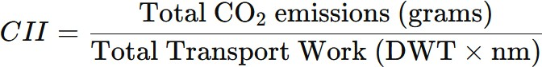

Date and time from (dd/mm/ yyyy; hh:mm UTC) | Date and time to (dd/mm/ yyyy; hh:mm UTC) | Distance travelled (n.m) | Hours under way (hh:mm) | **Exceptional conditions specified in Regulation 3.1 of MARPOL Annex VI (Y/N) | *Sailing in ice condition (Y/N) | “STS” Operation (Y/N) | Fuel consumption (metric tonnes)
 |  |  |  |  |  |  | total mass |  | **mass to be deducted from the total
 |  |  |  |  |  |  |  |  | consumed for production of electrical power FC Electrical |  | consumed by oil fired boiler consumed for cargo heating/discharge on tankers (FC Boiler)
Annual total

